**Icicles**

Last winter on a very cold day, Dennis was looking at the icicles hanging form the eve of this house and he began to wonder what words would look like if they were icicles. He got a piece of scratch paper and tried it out. He rewrote the words, “house”, “winter” and “cold” as if they were icicles hanging from his house. It came out like this:

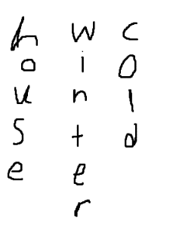

As you can see, Dennis’s penmanship is quite poor. So, to make his word icicles look better, Dennis decides he needs a program to read his words and print the icicles.

**Input:** The first line of input contains a value **T** that represents the number of test cases to follow. Each test case consists of a number **N** that represents the number of words followed by **N** words on separate lines.

**Output:** Each set of words printed side by side in columns spelled from the top down. There should be as many rows as there are characters in the longest word. Each set should be followed by a row of astericks (*) exactly as wide as the number of columns used to display the set.

**Example Input:**

2

3

House

Winter

Cold

5

Cat

Turtle

Aardvark

Dog

Fish

**Example Output:**

hwc

oio

unl

std

ee

r

***

ctadf

auaoi

trrgs

td h

lv

ea

r

k